MAP-8: An Integrated Roadmap for Correlational and Configurational Analysis in Management Research
Purpose
This study introduces MAP-8, an eight-step methodological roadmap that integrates correlational and configurational approaches, thereby enhancing analytical rigor and transparency in management research. The framework aims to guide researchers in systematically combining statistical precision with configurational reasoning to achieve deeper and more reliable insights into complex organizational phenomena.
Design/methodology/approach
MAP-8 structures the research process into sequential stages—from hypothesis formulation and data preparation to model estimation, interpretation, and replication. It integrates three complementary techniques: covariance-based structural equation modeling (CB-SEM) to test theoretical relationships, fuzzy-set qualitative comparative analysis (fsQCA) to capture causal complexity, and hierarchical clustering analysis to identify homogeneous data segments. The framework is applied to a case study examining affective commitment, organizational compatibility, and job satisfaction in telework contexts.
Findings
Results demonstrate that combining SEM, QCA, and clustering provides a more comprehensive understanding of organizational behavior, enabling researchers to uncover multiple causal pathways and validate theoretical constructs simultaneously. This methodological triangulation enhances the robustness, interpretability, and generalizability of findings.
Originality/value
MAP-8 contributes a structured, replicable, and interdisciplinary roadmap for integrating quantitative and configurational methods. It strengthens methodological coherence, supports mixed-method research, and facilitates evidence-based decision-making in organizational studies. The framework offers both researchers and practitioners a robust analytical framework for conducting theory-informed, data-driven investigations.

Keywords: Cluster analysis, Mixed methods, Model validation, Set theory, Structural equation models.
- Introduction
In organizational management research, traditional analytical methods have long relied on correlational approaches that assume linear relationships, where a change in one variable proportionally influences another (Khaw et al., 2022). However, such linear techniques often fall short of capturing the complexity and interdependence that characterize real-world organizational systems. These methods may obscure underlying dynamics and overlook nonlinear or conditional effects within the data (Bundy et al., 2017; Volk, 2017). By shifting toward set-based and configurational approaches, researchers can conceptualize variables as combinations of conditions with shared attributes, allowing for the exploration of multiple, interacting causal paths (Joshi and McKendall, 2018).
To better understand these intricate behaviors, scholars have increasingly adopted hybrid analytical methodologies that combine correlational and configurational techniques such as Structural Equation Modeling (SEM) (Sarstedt et al., 2022), fsQCA (Fernández-Esquinas et al., 2021), and hierarchical clustering analysis (HCA) (Saxena et al., 2017). While SEM excels in testing hypothesized linear relationships and assessing model fit, fsQCA and HCA uncover causal complexity and classify observations into meaningful groups. Recent studies have highlighted the advantages of integrating QCA with correlational methods (Parente and Federo, 2019; Valaei et al., 2019), though the potential of combining clustering techniques with these models remains less developed.
Empirical research increasingly demonstrates that merging SEM with clustering enhances analytical depth. For instance, SEM can establish causal pathways while clustering identifies latent profiles or homogeneous subgroups based on similar configurations (Tiengtavaj et al., 2017; Xi et al., 2024). This methodological synergy not only reinforces the validity of statistical results but also reveals nuanced behavioral or organizational patterns that linear analyses alone might miss (Chen et al., 2023). In organizational behavior and strategic management, combining SEM and clustering has enabled the classification of firms into distinct strategic or cultural profiles (Kolodiziev et al., 2022).
Hybrid methodological strategies therefore offer a multidimensional analytical perspective, as supported by Goertz and Mahoney (2012), who emphasize the complementarity of correlational and comparative approaches. Despite increasing recognition of configurational methods (Afonso et al., 2018; Drăgan et al., 2023; Jiang et al., 2016; Kaya et al., 2020; Loh et al., 2023; Mikalef and Pateli, 2017; Skarmeas et al., 2016; Tho and Trang, 2015; Urueña and Hidalgo, 2016; Vizcaíno and Chousa, 2016; Yueh et al., 2016), structured frameworks for effectively integrating them with correlational analyses remain scarce (Wu, 2016).
To address this gap, the present study introduces MAP-8, an eight-step framework integrating CB-SEM, fsQCA, and HCA. MAP-8 demonstrates how these methods can be jointly applied to enhance rigor, interpretability, and practical utility. Its application to a case on affective commitment, organizational compatibility, and job satisfaction in telework settings illustrates how combining SEM’s precision, fsQCA’s causal mapping, and HCA’s segmentation capacity enables richer, more valid insights into complex organizational phenomena..
- Theoretical Background
In social science research, including management studies, correlational and configurational analyses are widely used to identify relationships and uncover patterns within complex datasets (Grønmo, 2020). The correlational analysis measures the strength and direction of associations between two or more variables, while configurational analysis focuses on how combinations of variables contribute to specific outcomes (Thor and Beverly, 2014). Additionally, clustering techniques help identify latent structures by grouping observations based on similarities (Duarte-Duarte et al., 2021). Among these approaches, CB-SEM is a correlational technique, whereas fsQCA and HCA are configurational methodologies (Pappas and Woodside, 2021; Rasoolimanesh et al., 2021). These three analytical methods—CB-SEM, fsQCA, and HCA—complement one another, providing researchers with a robust framework for analyzing complex social phenomena.
  - Covariance-Based Structural Equation Modelling
CB-SEM is a rigorous statistical technique used to test theoretical models by simultaneously examining relationships between latent and observed variables. Unlike multiple regression or traditional factor analysis, CB-SEM evaluates all relationships together using the covariance matrix to determine how well the proposed model fits the observed data structure (Holey, 2012; Sarstedt and Cheah, 2019). Although it assumes continuous data, CB-SEM can also accommodate ordinal measures such as Likert scales through appropriate estimation methods (Li, 2016).
CB-SEM and Partial Least Squares SEM (PLS-SEM) represent two primary SEM approaches. While PLS-SEM is suited to exploratory research with small samples or limited theoretical foundations, CB-SEM is primarily confirmatory. It requires larger datasets, assumes multivariate normality, and provides higher statistical rigor when testing well-established theoretical frameworks (Hair et al., 2014).
Model fit in CB-SEM is assessed using multiple indices—such as the Chi-square test, Comparative Fit Index (CFI), Tucker-Lewis Index (TLI), and Root Mean Square Error of Approximation (RMSEA)—to determine how accurately the model reproduces observed covariances (Dash and Paul, 2021).
A standard CB-SEM process involves six stages: data preparation, model specification, parameter estimation, fit evaluation, re-specification, and reporting. During specification, researchers define latent constructs and their indicators based on theory; estimation then aligns the model’s implied covariance matrix with the empirical one. Poor model fit may require revising constructs or adjusting structural paths (Richter et al., 2016).
Despite its strengths, CB-SEM has limitations. It assumes linear relationships between latent and observed variables (Vonglao, 2017), struggles with non-linear dynamics, and performs poorly with small samples due to reduced statistical power (Dash and Paul, 2021; Jamshidian and Mata, 2007). Nevertheless, CB-SEM remains central to confirmatory modeling, providing a powerful and theoretically grounded framework for empirical validation.
  - Fuzzy Set Qualitative Comparative Analysis
Traditional correlational method often struggle to address the complexity inherent in social phenomena. fsQCA, together with clustering techniques, provides a robust alternative by revealing nuanced causal configurations that shape real-world outcomes and are often obscured by linear models (Ragin, 2014).
Developed by Charles Ragin, fsQCA bridges qualitative depth with quantitative rigor. Rooted in set theory and Boolean algebra, it goes beyond measuring associations to identify which combinations of conditions are necessary or sufficient for a given outcome. This enables the discovery of multiple, equally valid causal pathways—an idea known as equifinality. Such an approach is particularly valuable when analyzing nonlinear interactions that traditional regression techniques cannot adequately capture.
The broader family of QCA methods includes three main variants. Crisp-set QCA (csQCA) relies on binary classification (0 or 1) to assign cases to sets, which can oversimplify complex realities (Rihoux and Lobe, 2009). Multi-value QCA (mvQCA) introduces discrete categories to capture greater detail while maintaining set-theoretic logic (Cronqvist and Berg-Schlosser, 2009). fsQCA provides the most flexibility by allowing degrees of membership between 0 and 1, thus reflecting partial inclusion in a set. For example, rather than classifying a firm as simply “experienced” or “inexperienced,” fsQCA captures varying levels of experience (Ragin, 2008).
A central step in fsQCA is calibration, the process of transforming raw data into set membership scores based on theoretical justification and empirical context. Common strategies include mean-based calibration, where the average serves as a crossover point, and quantile-based calibration, which uses the 5th and 95th percentiles to define full non-membership and full membership, respectively Woodside (2013).
Despite its interpretive strength, fsQCA faces challenges due to the subjectivity of calibration and the lack of universal standards that can hinder cross-study comparability (Kacprzyk, 2009). Nevertheless, it remains an essential method for capturing causal complexity and understanding multiple pathways leading to similar outcomes in contexts where linear assumptions fall short.
  - Clustering techniques
Unlike fsQCA, which examines causal complexity, clustering focuses on identifying hidden patterns by grouping observations with shared characteristics. Its primary goal is to create internally consistent clusters—maximizing similarity within groups while maintaining clear distinctions between them (Bouveyron et al., 2019; Sun et al., 2017). This approach helps reveal latent structures in datasets and enhances the interpretation of heterogeneous populations.
Two of the most widely used techniques in the social sciences are Hierarchical Clustering and K-means Clustering, each with distinct advantages. Hierarchical clustering constructs a tree-like structure of nested groups based on distances between data points, either by merging individual observations (agglomerative) or splitting larger clusters (divisive). Dendrograms visualize this process, offering an intuitive representation of the data’s structure. In contrast, K-means clustering assigns observations to a predefined number of clusters (k) according to their proximity to centroids (Sinaga and Yang, 2020). Although computationally efficient, it requires careful selection of k, often guided by diagnostics such as the elbow or silhouette method.
Other approaches, like self-organizing maps (SOMs) and density-based clustering (DBSCAN), extend the method’s flexibility. DBSCAN, for instance, identifies clusters as dense regions without requiring a predefined number, effectively capturing irregular, non-spherical patterns (Schubert et al., 2017).
Historically, clustering in the social sciences traces back to Zubin (1938) personality typologies. Today, powered by machine learning, it is applied to unstructured data—text, images, and behaviors—using dimensionality reduction and automated feature extraction (Ertel, 2017). In management research, clustering supports analyses of financial, operational, and HR data (Grimmer et al., 2021; Ranta et al., 2022). Successful application depends on rigorous data preprocessing, including cleaning, normalization, and feature selection, as clustering is highly sensitive to input quality. Determining the optimal number of clusters remains a key interpretive challenge, balancing statistical precision with conceptual clarity.
  - Comparative Overview of Analytical Strategies in Social Science and Management
Table 1 concisely compares three prominent methodological approaches—CB-SEM, fsQCA, and clustering—highlighting their theoretical foundations, data requirements, strengths, limitations, and common applications. This comparative lens offers researchers practical guidance for selecting the most suitable analytical strategy, considering research goals, data characteristics, and interpretive needs.
Table 1 Comparison of Model Strategies in Social Science and Management
Aspect | CB-SEM | fsQCA | Clustering Techniques
Theory | Based on covariance, tests models with latent and observed variables. | Based on set theory and Boolean logic, it identifies causal conditions. | Uses algorithms to group similar data points.
Purpose | Confirm theoretical relationships. | Identifies combinations of conditions that lead to specific outcomes. | Detects patterns without predefined categories.
Data | Requires large samples and continuous or ordinal data, along with proper estimators. | Works with small to medium samples and utilizes calibrated data. | Flexible; accepts different types with preprocessing.
Assumptions | Assumes linearity, normality, and a theory-based model. | Assumes configurational causality and accurate calibration. | Assumes valid clusters; depends on scaling and similarity measures.
Advantages | Tests complex models, provides fit indices, supports latent variables. | Captures causal complexity, works with small sample sizes, and supports fuzziness. | Reveals patterns, handles large datasets, and different data types.
Limitations | Needs large data, assumes linearity, and is sensitive to misspecification. | Calibration is subjective; interpretation can be complex. | Subjective cluster number, sensitive to scaling and outliers.
Applications | Theory testing, latent constructs, model fit assessment. | Causal analysis, multiple pathways, small-sample research. | Market segmentation, behavioral patterns, exploratory analysis.
Outputs | Estimates (e.g., loadings), model fit indices. | Truth tables, consistency and coverage, and causal paths. | Cluster assignments, dendrograms, centroids.
Ease of Use | Requires statistical and software expertise. | Needs understanding of set theory and calibration. | Ease varies by method; tools widely available.
Software | AMOS, LISREL, Mplus, EQS. | fsQCA, R(QCA), Tosmana | R, Python (scikit-learn), SPSS, MATLAB.
A roadmap is a structured plan that outlines the key actions and milestones needed to achieve a specific objective. By organizing complex processes into clear stages, it facilitates the planning, development, and evaluation of research projects. Such frameworks help researchers visualize the sequence of activities, identify potential challenges, and ensure methodological coherence throughout the study (Thor and Beverly, 2014).
Building on this principle, the present study introduces an eight-stage roadmap designed to integrate SEM, fsQCA, and HCA for deeper analytical insights. The proposed MAP-8 (Modeling and Analysis Pipeline) simplifies the research process into eight sequential stages: (1) Hypothesis Definition, (2) Data Acquisition and Preparation, (3) Model Specification, (4) Model Estimation, (5) Fit Evaluation, (6) Model Interpretation, (7) Report Writing, and (8) Validation and Replication. This roadmap provides a cohesive framework that enhances analytical rigor, reproducibility, and interpretative depth in multi-method research (Figure 1)
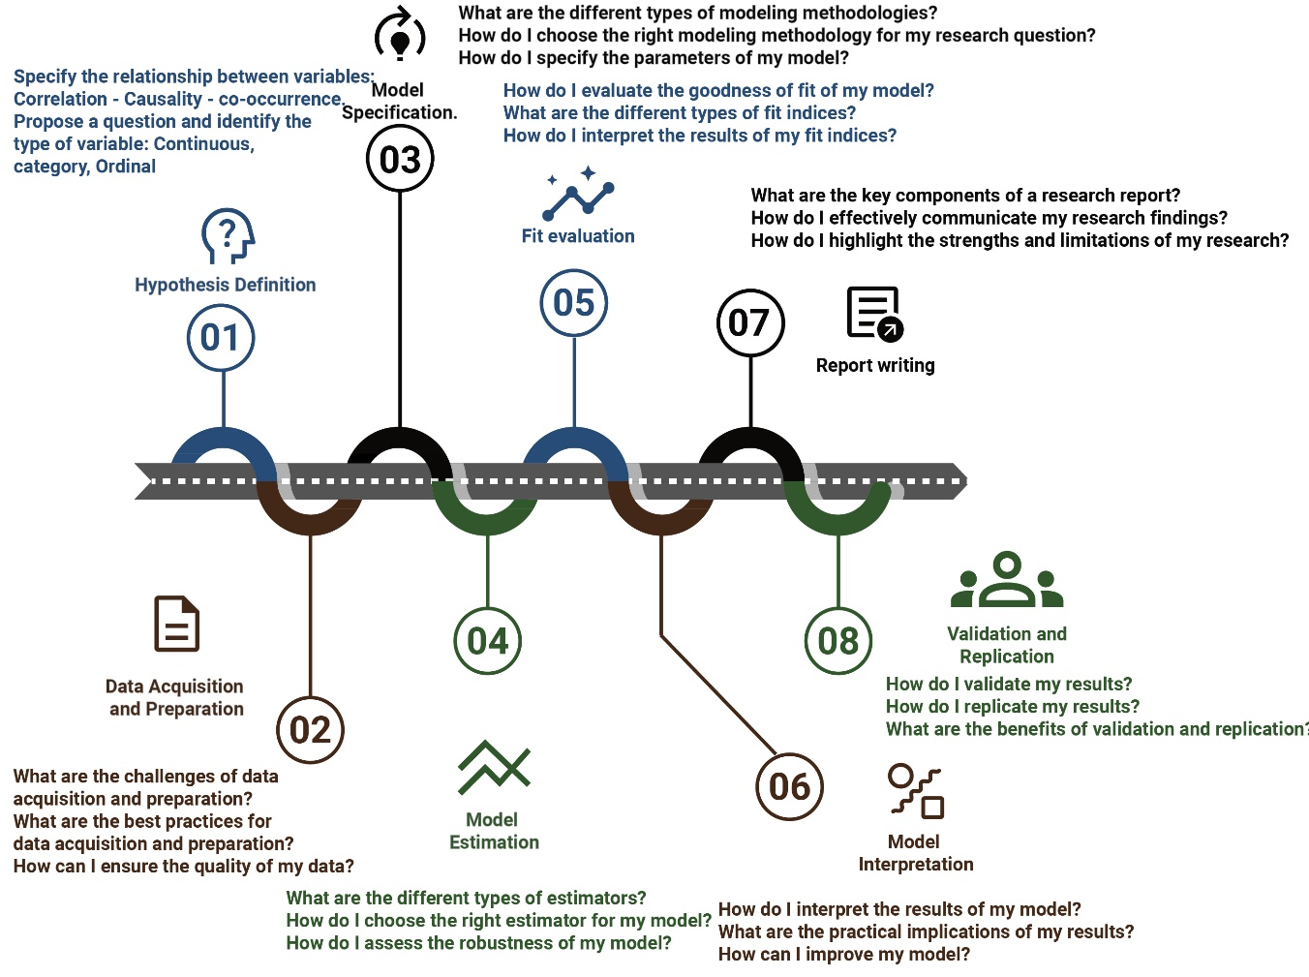
Figure 1 MAP-8 - Modeling and Analysis Pipeline
The roadmap aims to integrate the three approaches described in this study (SEM, fsQCA, and HCA) to enhance research insights. It is crucial to note that this road map serves as a general guideline, and the researcher should adapt it to the specific needs of each research endeavor. Researchers are encouraged to be flexible and open to adjusting the steps and methodologies to suit their unique research objectives and contexts. Each step is described as follows:
- Step 1: Hypothesis Definition. In this initial stage, the researcher formulates the research questions and hypotheses, defining the relationships between variables and expected outcomes. For instance, a researcher might hypothesize a direct relationship between employee job satisfaction and organizational commitment.
- Step 2: Data Acquisition and Preparation. This phase involves identifying suitable data sources (e.g., surveys, reports, interviews) and selecting an appropriate research design (correlational or configurational). The researcher determines the sampling strategy and data collection instruments, ensuring data quality through cleaning, transformation, and validation. Potential challenges, such as data accessibility and missing values, should be addressed through robust validation and preprocessing techniques. Assessing model assumptions at this stage is crucial, particularly for SEM applications.
- Step 3: Model Specification. At this stage, the researcher selects the appropriate analytical method—SEM, fsQCA, or HCA—based on the research question and dataset characteristics. Alternative methodologies, such as multiple regression, network analysis, or machine learning techniques, may be considered when appropriate.
- Step 4: Model Estimation This step focuses on estimating model parameters using the chosen methodology. The researcher selects appropriate estimators based on data characteristics and evaluates model robustness. Open-source tools such as R and Python offer viable alternatives for implementing these estimations.
- Step 5: Fit Evaluation. The researcher assesses the model’s goodness of fit by examining discrepancies between observed and estimated covariance matrices. Suppose the model does not adequately fit the data. Adjustments may be necessary in that case, including reformulating the model or selecting alternative data-driven techniques, such as trial-and-error empirical approaches or distance-based clustering methods.
- Step 6: Model Interpretation This stage involves interpreting the analysis results. The researcher examines the interrelated hypotheses linked to multiple theories, analyzes the meaning of particular parameters, reflects on causal effects, and reports the practical implications of the results. In this stage, the researcher could evaluate and adapt the last hypotheses based on the results.
- Step 7: Report Writing The final research report should clearly and concisely present the study’s findings, including an introduction, literature review, research questions, methodology, results, and discussion. It should also effectively communicate the study’s strengths, limitations, and implications.
- Step 8: Validation and Replication. To ensure the robustness and generalizability of findings, researchers should perform cross-validation, external validation with independent datasets, or replication studies. This step reinforces the credibility of the results and enhances the study’s contribution to the field.
- Materials and methods
This study follows the proposed MAP-8 roadmap to systematically investigate the relationships between Affective Commitment (AC), Organizational Compatibility (OC), and Job Satisfaction (JS) in a teleworking environment. This structured approach integrates CB-SEM, fsQCA, and HCA to examine both correlational and configurational perspectives. The case study, data collection procedures, and methodological framework are aligned with each step of the roadmap, ensuring a structured, replicable, and robust research design.
  - Step 1: Hypothesis Definition
The study is grounded in the theoretical framework of Organizational Behavior, which examines how employees interpret and react to workplace conditions. The transition to teleworking, necessitated by the COVID-19 pandemic, created a unique opportunity to explore how organizational factors influence employees’ commitment, perceived compatibility with their organization, and overall job satisfaction in a remote work setting. Building on prior research, this study formulates five hypotheses:
- H1: Affective Commitment is directly associated with Job Satisfaction.
- H2: Affective Commitment is directly associated with Organizational Compatibility.
- H3: Organizational Compatibility is a direct antecedent of Job Satisfaction.
- H4: Alternative configurations indicate equifinality in a teleworking environment, meaning multiple pathways can lead to high AC, OC, and JS.
- H5: The sample is heterogeneous, with distinct clusters exhibiting different levels of AC, OC, and JS.
  - Step 2: Data Acquisition and Preparation
The case study was conducted at a public university in Colombia, where employees—including full-time and adjunct professors, administrative personnel, and support staff—were required to telework during 2020–2021 due to the COVID-19 pandemic. The study examined a conceptual model linking three core constructs of Organizational Behaviour—Affective Commitment (AC), Organizational Compatibility (OC), and Job Satisfaction (JS)—within the teleworking environment. These constructs reflect how organizational members interpret workplace signals and transform them into perceptions and behaviors (García et al., 2020).
Teleworking is understood here as a labor arrangement supported by Information and Communication Technologies (ICTs) that enables employees to perform their functions remotely (Karácsony, 2021). Although teleworkers operate outside the employer’s premises, they continue to perceive, evaluate, and respond to organizational realities much like traditional on-site employees. The pandemic accelerated the adoption of this work modality worldwide, prompting growing academic interest in understanding teleworking behaviors and outcomes (Athanasiadou and Theriou, 2021; Cuerdo-Vilches et al., 2021). The sudden shift to remote work presented new human resource challenges, as professionals had to adapt to altered environments, digital constraints, and changing expectations, while many organizations recognized telework as a lasting element of their business models (OECD, 2021).
Within this context, the study revisits the three key constructs. Affective Commitment captures employees’ emotional attachment and sense of belonging to their organization (Jones and Volpe, 2011, p. 839). Compatibility reflects the alignment between personal and organizational values, principles, and strategies, achieved when employees’ psychological needs are met by their work environment (Rajaguru and Matanda, 2013). Job Satisfaction denotes the pleasurable emotional state derived from positive evaluations, affective experiences, and beliefs about one’s work (Syamsudin et al., 2022).
To test these relationships, a digital survey was administered to 173 university employees engaged in telework during the study period. The sample encompassed a diverse cross-section of the institution, including faculty, administrative, and service staff, providing a comprehensive view of organizational perceptions under remote working conditions.
- Eight demographic variables to capture respondent characteristics.
- 21 Likert-scale items (1 = strongly disagree, 5 = strongly agree) measuring three latent variables:
- Affective Commitment (AC) – six items (Meyer and Allen, 1991).
- Organizational Compatibility (OC) – five items (Resick et al., 2007).
- Job Satisfaction (JS) – eleven items (Lepold et al., 2018).
To assess data reliability and suitability, preliminary tests were conducted:
- Cronbach’s Alpha (0.92) confirmed high internal consistency.
- Kaiser-Meyer-Olkin (KMO) measure of 0.88 and Bartlett’s test of sphericity with χ² = 2302.58, p < 0.001 validated the dataset for factor analysis.
  - Step 3: Model Specification
The methodological framework integrates three complementary analytical techniques, each offering distinct insights into the research problem:
- CB-SEM: Examines linear relationships between AC, OC, and JS, testing the structural validity of the hypothesized model.
- fsQCA: Identifies causal configurations leading to high job satisfaction, capturing nonlinear effects overlooked by correlational methods.
- HCA: Segments respondents into distinct teleworker profiles, revealing patterns of commitment, compatibility, and satisfaction.
These approaches were selected to ensure a holistic analysis that accommodates both variable-centric and case-oriented perspectives. Alternative methodologies, such as multiple regression and network analysis, were considered but ultimately excluded due to their limitations in capturing causal complexity and heterogeneity within the dataset.
  - Step 4: Model Estimation
Each methodological approach was implemented using open-source statistical software, ensuring reproducibility and transparency:
- CB-SEM: Estimated using R (lavaan and semPlot packages) to assess structural relationships .
- fsQCA: Applied using R (QCA package) to calibrate and analyze configurational dependencies (Duşa, 2007).
- HCA: Conducted in Python (Scikit-learn and Matplotlib), using complete linkage and Manhattan distance for clustering.
Data transformations were performed according to the assumptions of each method, ensuring consistency across analyses.
  - Step 5: Fit Evaluation
To determine model adequacy, key fit indices and calibration measures were examined:
- CB-SEM: CFI (0.820), TLI (0.798), and RMSEA (0.105) suggest suboptimal model fit, indicating the need for refinement.
- fsQCA Calibration: Fuzzy-set membership thresholds were established at 0.05 (full non-membership), 0.50 (crossover point), and 0.95 (full membership) (Ragin, 2014).
- Clustering Criteria: Hierarchical clustering applied Manhattan distance to segment participants into three clusters, reflecting low, moderate, and high AC, OC, and JS.
  - Step 6: Model Interpretation
Findings from each approach were synthesized to develop a comprehensive understanding of the research question:
- CB-SEM: Provided insights into direct relationships between AC, OC, and JS but required refinements due to marginal fit.
- fsQCA: Identified necessary conditions, revealing that high Affective Commitment and Organizational Compatibility are prerequisites for high Job Satisfaction.
- HCA: Differentiated respondents into three distinct teleworker profiles, highlighting variability in commitment, compatibility, and satisfaction levels.
  - Step 7: Report Writing
The research findings were structured into a detailed report using this scientific article as a driver for methodology implementation with a special focus on model complementarity.
  - Validation and Replication
Additional steps were taken to ensure robustness and generalizability, including cross-validating fsQCA results by testing alternative calibration thresholds and various distance metrics in the AHC. Furthermore, the roadmap was structured to facilitate future applications in similar organizational contexts.
- Results and discussion
  - Results
    - Descriptive analysis
The initial data exploration reveals consistent and meaningful relationships among the constructs. As shown in Figure 2, all variables exhibit positive inter-item correlations, indicating that higher levels of AC are associated with stronger perceptions of OC and greater JS. This coherence lays a solid foundation for subsequent analyses. Mean values for AC items range from 4.30 to 4.81, indicating that participants generally have a high emotional attachment to their organizations—a factor often linked to improved performance, reduced turnover intentions, and higher satisfaction.
In the case of OC, the mean falls between 3.57 and 4.21, suggesting a moderate to strong alignment between personal and organizational values. Employees who perceive such alignment tend to exhibit greater loyalty and workplace satisfaction. The mean values for JS items range from 3.63 to 4.47, indicating moderate to high levels of job contentment. Research consistently links job satisfaction to improved performance and enhanced overall well-being.
The dataset’s robustness was confirmed through a reliability analysis, which revealed excellent internal consistency (Cronbach’s alpha = 0.92) and strong sampling adequacy (KMO = 0.88). Additionally, Bartlett’s test produced a significant chi-squared value (χ² = 2302.58, p < 0.001), confirming the factorability of the correlation matrix. In conjunction with the correlation heatmap in Figure 2, these results indicate that the dataset meets the reliability and validity requirements for subsequent structural modeling.

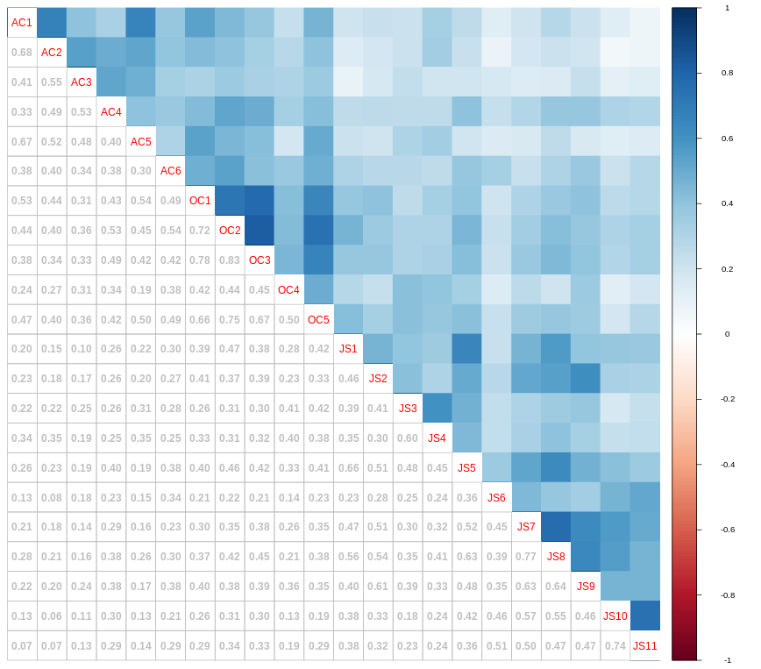
Figure 2 Heatmap correlation between variables
    - CB-SEM
The CB-SEM model, developed to test the first three hypotheses, comprised 47 parameters and was evaluated using multiple fit indices. Unfortunately, the model demonstrated suboptimal fit: a significant chi-square (p < 0.05), CFI (0.820), TLI/NNFI (0.798), and RMSEA (0.105), all pointing to a need for model revision. Additional indices, such as SRMR (0.089) and AGFI (0.702), corroborated this finding. The AIC (8509.29) and BIC (8657.49) also suggested room for improvement.
Although the model offers a sophisticated view of variable interrelations, its current structure appears strained—possibly overfitted or missing crucial paths. Under these conditions, accepting or rejecting hypotheses would be premature. A careful re-specification is necessary to ensure theoretical integrity without overcomplicating the structure.
    - fsQCA
Shifting from linear modeling to configurational logic, fsQCA offers a distinct vantage point. Constructs were synthesized by averaging observed variables (Figure 3), and the analysis focused on identifying necessary conditions for the outcomes. The findings reveal Affective Commitment as a necessary antecedent for both Organizational Compatibility and Job Satisfaction (inclN = 0.86; covN = 0.72).
Notably, OC is also necessary for AC (inclN = 0.81; covN = 0.74), suggesting a reciprocal dependency. For JS, the combined presence of AC and OC emerges as essential (inclN = 0.84; covN = 0.68). These results suggest that fostering emotional engagement and value alignment is vital for building a satisfied and committed workforce. However, having one without the other does not ensure high satisfaction—emphasizing the importance of configurational thinking.
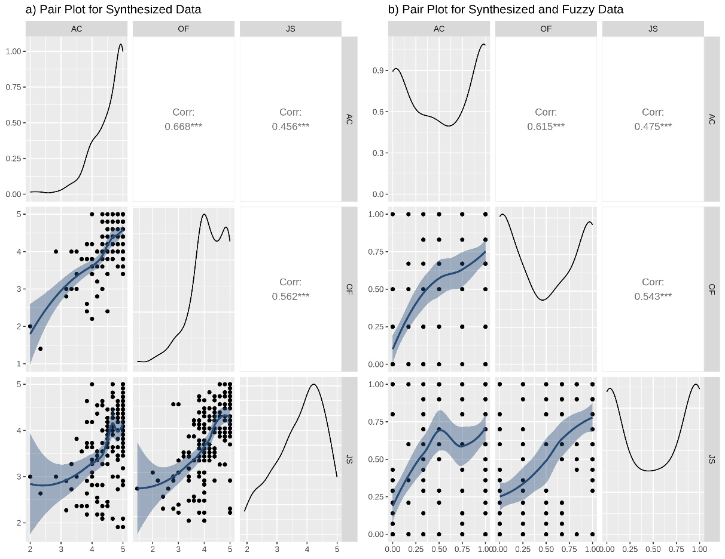
Figure 3 Variables synthesized into constructs
    - HCA
HCA uncovered four distinct employee clusters based on AC, OC, and JS scores (Figure 4). Cluster 1, the smallest, represents employees with consistently low scores across all three constructs—likely indicating disengagement and misalignment. Cluster 2, by contrast, features the highest average scores, representing highly committed, aligned, and satisfied employees. Cluster 3 captures a middle ground, with average scores across constructs, while Cluster 4 appears heterogeneous and requires closer examination.
These clusters provide valuable insights for tailored organizational interventions. Yet, interpretation must account for size and internal variability. While small clusters may lack statistical power, large ones can obscure subgroup differences, thereby complicating the development of targeted strategies.
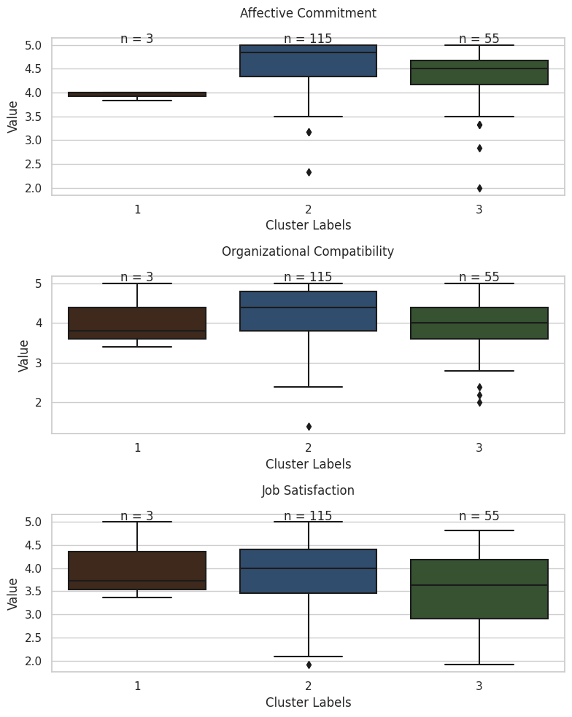
Figure 4 Boxplot by cluster
    - Integrating Multiple Analytical Perspectives
Together, CB-SEM, fsQCA, and HCA offer a panoramic view of the data. CB-SEM maps complex theoretical structures but calls for refinement due to its less-than-ideal fit. fsQCA identifies key causal conditions, highlighting the intertwined roles of AC and OC in shaping outcomes such as JS. HCA, meanwhile, segments the population into meaningful clusters, offering practical implications for differentiated HR strategies.
This study illustrates the power of methodological pluralism by applying these three methods to the same dataset. CB-SEM offers analytical rigor, fsQCA brings explanatory nuance, and HCA supports actionable segmentation. Collectively, they deliver a richer, more multidimensional understanding of how affective bonds and organizational alignment influence job satisfaction.
  - Discussion
This study underscores the value of integrating correlational, configurational, and clustering methodologies to strengthen analytical insight in management research. While techniques such as SEM, fsQCA, and HCA have been applied independently, few studies have explored their combined potential within a structured and replicable framework. The proposed MAP-8 roadmap addresses this gap by offering a systematic process for methodological integration, improving both rigor and reproducibility.
Each method contributes unique strengths: SEM quantifies direct and indirect relationships, fsQCA captures causal complexity and identifies multiple pathways to the same outcome, and clustering uncovers latent structures by grouping similar cases (Valaei et al., 2019). When triangulated, these techniques enhance result validity, reveal hidden interactions, and enrich theoretical interpretation. Transparent reporting and sensitivity analyses further reinforce the credibility of multi-method designs.
Despite their advantages, multi-method strategies face institutional and practical barriers. Academic traditions frequently favor single-method studies, discouraging methodological diversity (Drăgan et al., 2023; Loh et al., 2023; Tho and Trang, 2015; Yueh et al., 2016). Moreover, methodological inconsistencies arise when instruments are tailored solely for one approach—often SEM—reducing adaptability for fsQCA or HCA applications and occasionally yielding counterintuitive findings (Tho and Trang, 2015). Interdisciplinary collaboration also presents challenges, as researchers from statistics, psychology, and engineering bring divergent methodological orientations. Limited cross-method training further constrains the synthesis of complementary insights.

To address these issues, data collection tools should be designed to support multiple analytical techniques, particularly those combining correlational and configurational methods. Encouraging interdisciplinary collaboration can foster richer interpretations and methodological innovation. Publishing comparative or hybrid applications will promote inclusiveness and advance theoretical development.
At a conceptual level, correlational and configurational logic differ fundamentally. SEM explores linear associations, fsQCA reveals non-linear and asymmetric causal configurations, and HCA identifies subgroups that clarify or contextualize relationships. Scholars such as Thor and Trang have advocated for fsQCA as a complement to PLS-SEM, enriching causal interpretation within regression-based frameworks (Grønmo, 2020). The principle of equifinality (Fiss, 2011; Goertz and Mahoney, 2012). emphasizes that multiple causal paths can yield the same outcome, a concept particularly relevant in strategic and crisis communication studies (Bundy et al., 2017; Joshi and McKendall, 2018; Volk, 2017).
Ultimately, this study contributes to the advancement of management research by proposing a flexible yet systematic approach that integrates correlational precision, configurational depth, and clustering’s pattern recognition. As organizational phenomena grow in complexity, frameworks such as MAP-8 will be essential for producing theory-informed, methodologically sound, and contextually meaningful insights.
- Conclusions
This study highlights the complementary value of integrating SEM, QCA, and clustering to enhance methodological diversity in research. Each technique contributes unique strengths: SEM ensures statistical rigor through hypothesis testing and error control; QCA, especially in its fuzzy-set form, captures causal complexity and multiple pathways; and clustering identifies natural data patterns for exploratory insights.
Their combined use strengthens analytical depth—clustering organizes data into homogeneous groups, SEM validates theoretical models, and QCA reveals nuanced causal configurations. This synergy supports both theory testing and discovery. The MAP-8 roadmap proposed in this study provides a structured guide for integrating these methods —from hypothesis formulation to validation —promoting coherence and replicability.
Overall, this integrative framework encourages researchers to move beyond reliance on a single method, fostering methodological flexibility and improving the robustness, interpretability, and relevance of empirical findings.
References
Afonso, C., Silva, G.M., Gonçalves, H.M. and Duarte, M. (2018), “The role of motivations and involvement in wine tourists’ intention to return: SEM and fsQCA findings”, Journal of Business Research, Vol. 89, pp. 313 – 321, doi: 10.1016/j.jbusres.2017.11.042.
Athanasiadou, C. and Theriou, G. (2021), “Telework: systematic literature review and future research agenda”, Heliyon, Vol. 7 No. 10, p. e08165, doi: 10.1016/j.heliyon.2021.e08165.
Bouveyron, C., Celeux, G., Murphy, T.B. and Raftery, A.E. (2019), Model-Based Clustering and Classification for Data Science, 1st ed., Vol. 1, Cambridge University Press, doi: 10.1017/9781108644181.
Bundy, J., Pfarrer, M.D., Short, C.E. and Coombs, W.T. (2017), “Crises and Crisis Management: Integration, Interpretation, and Research Development”, Journal of Management, Vol. 43 No. 6, pp. 1661–1692, doi: 10.1177/0149206316680030.
Chen, R., Wang, S., Zhu, Z., Yu, J. and Dang, C. (2023), “Credit ratings of Chinese online loan platforms based on factor scores and K-means clustering algorithm”, Journal of Management Science and Engineering, Vol. 8 No. 3, doi: 10.1016/j.jmse.2022.12.003.
Cronqvist, L. and Berg-Schlosser, D. (2009), “Multi-Value QCA (mvQCA)”, Configurational Comparative Methods: Qualitative Comparative Analysis (QCA) and Related Techniques, SAGE Publications, Inc., 2455 Teller Road, Thousand Oaks California 91320 United States, pp. 69–86, doi: 10.4135/9781452226569.n4.
Cuerdo-Vilches, T., Navas-Martín, M.Á. and Oteiza, I. (2021), “Working from Home: Is Our Housing Ready?”, International Journal of Environmental Research and Public Health, Multidisciplinary Digital Publishing Institute, Vol. 18 No. 14, p. 7329, doi: 10.3390/IJERPH18147329.
Dash, G. and Paul, J. (2021), “CB-SEM vs PLS-SEM methods for research in social sciences and technology forecasting”, Technological Forecasting and Social Change, Vol. 173, doi: 10.1016/j.techfore.2021.121092.
Drăgan, G.B., Ben Arfi, W., Tiberius, V. and Ammari, A. (2023), “Gravitating exogenous shocks to the next normal through entrepreneurial coopetive interactions: A PLS-SEM and fsQCA approach”, Journal of Business Research, Vol. 157, doi: 10.1016/j.jbusres.2022.113627.
Duarte-Duarte, J.B., Talero-Sarmiento, L.H. and Rodríguez-Padilla, D.C. (2021), “Methodological proposal for the identification of tourist routes in a particular region through clustering techniques”, Heliyon, Vol. 7 No. 4, doi: 10.1016/j.heliyon.2021.e06655.
Duşa, A. (2007), “User manual for the QCA(GUI) package in R”, Journal of Business Research, Vol. 60 No. 5, pp. 576–586, doi: 10.1016/j.jbusres.2007.01.002.
Ertel, W. (2017), “Machine Learning and Data Mining”, Introduction to Artificial Intelligence, pp. 175–243, doi: 10.1007/978-3-319-58487-4_8.
Fernández-Esquinas, M., Sánchez-Rodríguez, M.I., Pedraza-Rodríguez, J.A. and Muñoz-Benito, R. (2021), “The use of QCA in science, technology and innovation studies: a review of the literature and an empirical application to knowledge transfer”, Scientometrics, Vol. 126 No. 8, pp. 6349–6382, doi: 10.1007/s11192-021-04012-y.
Fiss, P.C. (2011), “Building Better Causal Theories: A Fuzzy Set Approach to Typologies in Organization Research”, Academy of Management Journal, Vol. 54 No. 2, pp. 393–420, doi: 10.5465/AMJ.2011.60263120.
García, C.I., Celis, E.A. and Contreras-Pacheco, O.E. (2020), “Identificación Profesional y Comportamiento Organizacional de los Profesionales de la Comunicación”, Suma de Negocios, Vol. 11 No. 25, pp. 139–148, doi: 10.14349/sumneg/2020.v11.n25.a5.
Goertz, G. and Mahoney, J. (2012), “Scope in Case Study Research”, The SAGE Handbook of Case-Based Methods, doi: 10.4135/9781446249413.n18.
Grimmer, J., Roberts, M.E. and Stewart, B.M. (2021), “Machine Learning for Social Science: An Agnostic Approach”, Annual Review of Political Science, Vol. 24 No. 1, pp. 395–419, doi: 10.1146/annurev-polisci-053119-015921.
Grønmo, S. (2020), Social Research Methods: Qualitative, Quantitative and Mixed Methods Approaches, Book:
Hair, J.F., Black, W.C., Babin, B.J., Anderson, R.E. and Tatham, R.L. (2014), Multivariate Data Analysis, Multivariate Data Analysis, Pearson.
Holey, R.H. (2012), Handbook of Structural Equation Modeling, edited by Kaplan, D., Marcoulides, G.A. and West, S.G.Handbook of Structural Equation Modeling, 1st ed., The Guilford Press, New York.
Jamshidian, M. and Mata, M. (2007), “Advances in Analysis of Mean and Covariance Structure when Data are Incomplete”, Handbook of Latent Variable and Related Models, Elsevier, pp. 21–44, doi: 10.1016/B978-044452044-9/50005-7.
Jiang, T.-H., Chen, S.-L. and Chen, J.K.C. (2016), “Examining the role of behavioral intention on multimedia teaching materials using FSQCA”, Journal of Business Research, Vol. 69 No. 6, pp. 2252 – 2258, doi: 10.1016/j.jbusres.2015.12.038.
Jones, C. and Volpe, E.H. (2011), “Organizational identification: Extending our understanding of social identities through social networks”, Journal of Organizational Behavior, Vol. 32 No. 3, pp. 413–434.
Joshi, M. and McKendall, M. (2018), “Responses to the Discovery of Unethical Acts: An Organizational Identity and Reputation Perspective”, Business & Society, Vol. 57 No. 4, pp. 706–741, doi: 10.1177/0007650315623953.
Kacprzyk, J. (2009), “Fuzzy Sets Theory, Foundations of”, Encyclopedia of Complexity and Systems Science, Springer New York, New York, NY, pp. 4059–4080, doi: 10.1007/978-0-387-30440-3_238.
Karácsony, P. (2021), “Impact of teleworking on job satisfaction among Slovakian employees in the era of COVID-19”, Problems and Perspectives in Management, Vol. 19 No. 3, pp. 1–10, doi: 10.21511/ppm.19(3).2021.01.
Kaya, B., Abubakar, A.M., Behravesh, E., Yildiz, H. and Mert, I.S. (2020), “Antecedents of innovative performance: Findings from PLS-SEM and fuzzy sets (fsQCA)”, Journal of Business Research, Vol. 114, pp. 278 – 289, doi: 10.1016/j.jbusres.2020.04.016.
Khaw, K.W., Alnoor, A., AL-Abrrow, H., Tiberius, V., Ganesan, Y. and Atshan, N.A. (2022), “Reactions towards organizational change: a systematic literature review”, Current Psychology, doi: 10.1007/s12144-022-03070-6.
Kolodiziev, O., Shcherbak, V., Vzhytynska, K., Chernovol, O. and Lozynska, O. (2022), “Clustering of banks by the level of digitalization in the context of the COVID-19 pandemic”, Banks and Bank Systems, Vol. 17 No. 1, doi: 10.21511/bbs.17(1).2022.07.
Lepold, A., Tanzer, N., Bregenzer, A. and Jiménez, P. (2018), “The Efficient Measurement of Job Satisfaction: Facet-Items versus Facet Scales”, International Journal of Environmental Research and Public Health, Vol. 15 No. 7, doi: 10.3390/ijerph15071362.
Li, C.-H. (2016), “Confirmatory factor analysis with ordinal data: Comparing robust maximum likelihood and diagonally weighted least squares”, Behavior Research Methods, Vol. 48 No. 3, pp. 936–949, doi: 10.3758/s13428-015-0619-7.
Loh, X.-M., Lee, V.-H., Leong, L.-Y., Aw, E.C.-X., Cham, T.-H., Tang, Y.-C. and Hew, J.-J. (2023), “Understanding consumers’ resistance to pay with cryptocurrency in the sharing economy: A hybrid SEM-fsQCA approach”, Journal of Business Research, Vol. 159, doi: 10.1016/j.jbusres.2023.113726.
Meyer, J.P. and Allen, N.J. (1991), “A Three-Component Conceptualization of Organizational Commitment”, Human Resource Management Review, Vol. 1 No. 1, pp. 61–89.
Mikalef, P. and Pateli, A. (2017), “Information technology-enabled dynamic capabilities and their indirect effect on competitive performance: Findings from PLS-SEM and fsQCA”, Journal of Business Research, Vol. 70, pp. 1 – 16, doi: 10.1016/j.jbusres.2016.09.004.
OECD. (2021), Teleworking in the COVID-19 Pandemic: Trends and Prospects, doi: 10.1787/72a416b6-en.
Pappas, I.O. and Woodside, A.G. (2021), “Fuzzy-set Qualitative Comparative Analysis (fsQCA): Guidelines for research practice in Information Systems and marketing”, International Journal of Information Management, Vol. 58, p. 102310, doi: 10.1016/j.ijinfomgt.2021.102310.
Parente, T.C. and Federo, R. (2019), “Qualitative comparative analysis: justifying a neo-configurational approach in management research”, RAUSP Management Journal, Vol. 54 No. 4, doi: 10.1108/RAUSP-05-2019-0089.
Ragin, C.C. (2008), Redesigning Social Inquiry, University of Chicago Press, doi: 10.7208/chicago/9780226702797.001.0001.
Ragin, C.C. (2014), The Comparative Method: Moving Beyond Qualitative and Quantitative Strategies, edited by University of California Press, 1st ed., University of California Press, California.
Rajaguru, R. and Matanda, M.J. (2013), “Effects of inter-organizational compatibility on supply chain capabilities: Exploring the mediating role of inter-organizational information systems (IOIS) integration”, Industrial Marketing Management, Vol. 42 No. 4, pp. 620–632, doi: 10.1016/j.indmarman.2012.09.002.
Ranta, M., Ylinen, M. and Järvenpää, M. (2022), “Machine Learning in Management Accounting Research: Literature Review and Pathways for the Future”, European Accounting Review, pp. 1–30, doi: 10.1080/09638180.2022.2137221.
Rasoolimanesh, S.M., Ringle, C.M., Sarstedt, M. and Olya, H. (2021), “The combined use of symmetric and asymmetric approaches: partial least squares-structural equation modeling and fuzzy-set qualitative comparative analysis”, International Journal of Contemporary Hospitality Management, Vol. 33 No. 5, pp. 1571–1592, doi: 10.1108/IJCHM-10-2020-1164.
Resick, C.J., Baltes, B.B. and Shantz, C.W. (2007), “Person-Organization Fit and Work-Related Attitudes and Decisions: Examining Interactive Effects With Job Fit and Conscientiousness”, Journal of Applied Psychology, Vol. 92 No. 5, pp. 1446–1455, doi: 10.1037/0021-9010.92.5.1446.
Richter, N.F., Sinkovics, R.R., Ringle, C.M. and Schlägel, C. (2016), “A critical look at the use of SEM in international business research”, edited by R. Sinkovics, Ruey-Jer “Bryan” Jean and Daekwan Kim, R.International Marketing Review, Vol. 33 No. 3, pp. 376–404, doi: 10.1108/IMR-04-2014-0148.
Rihoux, B. and Lobe, B. (2009), “The Case for Qualitative Comparative Analysis (QCA): Adding Leverage for Thick Cross-Case Comparison”, The SAGE Handbook of Case-Based Methods, SAGE Publications Ltd, 1 Oliver’s Yard, 55 City Road, London EC1Y 1SP United Kingdom, pp. 222–242, doi: 10.4135/9781446249413.n13.
Sarstedt, M. and Cheah, J.-H. (2019), “Partial least squares structural equation modeling using SmartPLS: a software review”, Journal of Marketing Analytics, Vol. 7 No. 3, pp. 196–202, doi: 10.1057/s41270-019-00058-3.
Sarstedt, M., Radomir, L., Moisescu, O.I. and Ringle, C.M. (2022), “Latent class analysis in PLS-SEM: A review and recommendations for future applications”, Journal of Business Research, Vol. 138, pp. 398–407, doi: 10.1016/j.jbusres.2021.08.051.
Saxena, A., Prasad, M., Gupta, A., Bharill, N., Patel, O.P., Tiwari, A., Er, M.J., et al. (2017), “A review of clustering techniques and developments”, Neurocomputing, Vol. 267, pp. 664–681, doi: 10.1016/j.neucom.2017.06.053.
Schubert, E., Sander, J., Ester, M., Kriegel, H.P. and Xu, X. (2017), “DBSCAN revisited, revisited: Why and how you should (still) use DBSCAN”, ACM Transactions on Database Systems, Vol. 42 No. 3, doi: 10.1145/3068335.
Sinaga, K.P. and Yang, M.S. (2020), “Unsupervised K-means clustering algorithm”, IEEE Access, Vol. 8, doi: 10.1109/ACCESS.2020.2988796.
Skarmeas, D., Lisboa, A. and Saridakis, C. (2016), “Export performance as a function of market learning capabilities and intrapreneurship: SEM and FsQCA findings”, Journal of Business Research, Vol. 69 No. 11, pp. 5342 – 5347, doi: 10.1016/j.jbusres.2016.04.135.
Sun, L., Chen, G., Xiong, H. and Guo, C. (2017), “Cluster Analysis in Data‐Driven Management and Decisions”, Journal of Management Science and Engineering, Vol. 2 No. 4, doi: 10.3724/SP.J.1383.204011.
Syamsudin, N., Eliyana, A., Nurdin, N., Sudrajat, A., Giyanto, B., Emur, A.P. and Zahar, M. (2022), “Are job satisfaction and role breadth self-efficacy the links to proactive work behavior?”, Heliyon, Vol. 8 No. 1, p. e08710, doi: 10.1016/j.heliyon.2021.e08710.
Tho, N.D. and Trang, N.T.M. (2015), “Can knowledge be transferred from business schools to business organizations through in-service training students? SEM and fsQCA findings”, Journal of Business Research, Vol. 68 No. 6, pp. 1332 – 1340, doi: 10.1016/j.jbusres.2014.12.003.
Thor, I.H. and Beverly, P. (2014), “Drafting a Research Roadmap”, Procedia - Social and Behavioral Sciences, Vol. 119, pp. 719–724, doi: 10.1016/j.sbspro.2014.03.080.
Tiengtavaj, S., Phimonsathienand, T. and Fongsuwan, W. (2017), “Ensuring Competitive Advantage through Innovation Capability and Clustering in the Thai Automotive Parts Molding Industry: A SEM Approach”, Management and Production Engineering Review, Vol. 8 No. 1, doi: 10.1515/mper-2017-0010.
Urueña, A. and Hidalgo, A. (2016), “Successful loyalty in e-complaints: FsQCA and structural equation modeling analyses”, Journal of Business Research, Vol. 69 No. 4, pp. 1384 – 1389, doi: 10.1016/j.jbusres.2015.10.112.
Valaei, N., Rezaei, S., Ho, R.C. and Okumus, F. (2019), “Beyond Structural Equation Modelling in Tourism Research: Fuzzy Set/Qualitative Comparative Analysis (fs/QCA) and Data Envelopment Analysis (DEA)”, Perspectives on Asian Tourism, Vol. Part F184, doi: 10.1007/978-981-13-2463-5_14.
Vizcaíno, M. and Chousa, J.P. (2016), “Analyzing the influence of the funds’ support on Tobin’s q using SEM and fsQCA”, Journal of Business Research, Vol. 69 No. 6, pp. 2118 – 2124, doi: 10.1016/j.jbusres.2015.12.018.
Volk, S.C. (2017), “Towards Comparative Research in Strategic Communication: A Systematic Analysis of Cross-National Studies and Future Directions.”, International Journal of Strategic Communication, Routledge, Vol. 11 No. 5, pp. 434–453, doi: 10.1080/1553118X.2017.1360891.
Vonglao, P. (2017), “Application of fuzzy logic to improve the Likert scale to measure latent variables”, Kasetsart Journal of Social Sciences, Vol. 38 No. 3, pp. 337–344, doi: 10.1016/j.kjss.2017.01.002.
Woodside, A.G. (2013), “Moving beyond multiple regression analysis to algorithms: Calling for adoption of a paradigm shift from symmetric to asymmetric thinking in data analysis and crafting theory”, Journal of Business Research, Vol. 66 No. 4, pp. 463–472, doi: 10.1016/j.jbusres.2012.12.021.
Wu, C.-W. (2016), “Global entrepreneurship and innovation in management: Comparing MRA/SEM versus fuzzy-set QCA theory creation, data analysis, and findings”, Journal of Business Research, Vol. 69 No. 6, pp. 2061–2066, doi: 10.1016/j.jbusres.2015.12.009.
Xi, J., Wen, C., Tang, Y. and Zhao, F. (2024), “A factor score clustering approach to analyze the biopharmaceutical sector in the Chinese market during COVID-19”, Financial Innovation, Vol. 10 No. 1, p. 135, doi: 10.1186/s40854-024-00654-y.
Yueh, H.-P., Lu, M.-H. and Lin, W. (2016), “Employees’ acceptance of mobile technology in a workplace: An empirical study using SEM and fsQCA”, Journal of Business Research, Vol. 69 No. 6, pp. 2318 – 2324, doi: 10.1016/j.jbusres.2015.12.048.
Zubin, J. (1938), “A technique for measuring like-mindedness.”, The Journal of Abnormal and Social Psychology, Vol. 33 No. 4, pp. 508–516, doi: 10.1037/h0055441.

